An important part of the financial planning process is undertaking your personal risk investment profile. The assessment of your investment risk profile is central to the investment solutions to best meet your current needs and future aspirations for the construction of your investment portfolio.

Investment Risk Profile
Private & Confiential
(Version 1.1 April 2024)

Client 1:
Client 2:
Date Completed:

Life Map Financial Planning Pty Ltd
ABN:99 637 766 762
AFSL No.523004
Level 3
14 Martin Place
SYDNEY NSW 2000
Phone: (02) 9639 9334
Important Investment Information to Consider
This booklet will help us to understand your tolerance to risk and determine an appropriate risk profile.
Different people are comfortable with different levels of risk. A person's risk tolerance is the level of risk with which he or she is comfortable.
By asking certain questions, we will identify what you would do in such circumstances, regardless of whether you have been in them or are ever likely to be in them. Your answer to a specific question may be influenced by a particular experience, mood, or feeling at the time.
Some questions give you a limited choice of responses and may not include what would be your preferred answer. These questions are designed to gain an idea of what you would do given the limited information.
Understanding, identifying, and agreeing on your risk profile is a critical step in designing the right investment strategy to meet your goals and objectives while considering your tolerance to risk.
Risks Associated with Investing
Any investment decision you make means that you must take a risk of some sort. The decision will directly relate to the amount of money you invest, your circumstances at the time, and your needs for the future. If you have a better understanding of risk, you can make a more informed investment decision, accepting some risks and rejecting others. The important point is that you understand the relationship between risk and reward, particularly over your investment time frame.
There are various risks associated with all investments. These include inflation, volatility, market risk, specific risk, and legislative risk.
What is the Relationship between Risk and Return?
Risk and return are positively correlated. In real terms, this means, that the higher the risk associated with an investment, the higher the expected return, and vice versa. This relationship is called the ‘Risk vs. Return Trade Off’ (see chart below) and is a factor that is taken into consideration in defining your tolerance to risk. Investments such as shares may offer higher returns over the longer term, but there is a greater inherent risk. In contrast, cash and fixed-interest investments are considered to be less risky but offer lower returns.
The relationship between risk and return in different asset classes is illustrated in this graph.

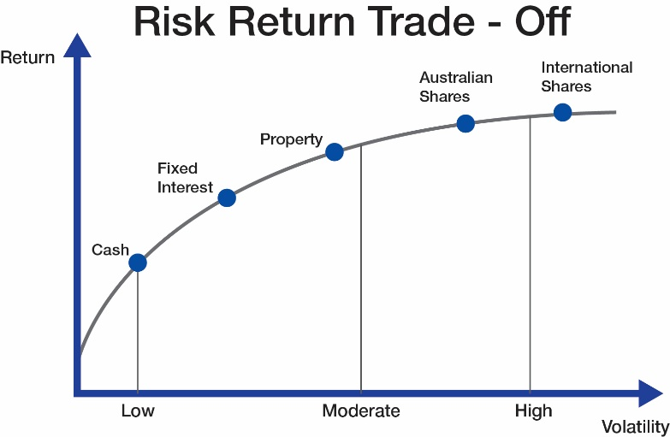

Carefully read the following questions and select the answer you most agree with:
- How much knowledge do you have of investment markets? | Client 1 | Client 2
I don’t have any knowledge about investment markets. | 1 | 1
I have a small amount of knowledge about investment markets. | 2 | 2
I have a small amount of knowledge and I am keen to know more. | 3 | 3
I have some knowledge about investment markets and occasionally hear or read about them and understand that returns can vary. | 4 | 4
I actively read about the markets and understand that investment sectors or assets have different returns and risks. | 5 | 5

- An investment you have made recently in a popular and well-known share has fallen in value (by 20%), What would you do? | Client 1 | Client 2
I would lose confidence in investing in growth assets. | 1 | 1
Sell the investment immediately so I don’t lose any more money. | 2 | 2
Do nothing because I feel that it will rise in value again. | 3 | 3
Put in more money now, while values are down to get a bargain. | 4 | 4
Actively pursue further funds to invest including using borrowed funds. | 5 | 5

- How long are you planning to invest the majority of your money before spending it (including after your retirement)? | Client 1 | Client 2
Less than 2 years | 1 | 1
2 to 4 years | 2 | 2
4 to 7 years | 3 | 3
7 to 10 years | 4 | 4
More than 10 years | 5 | 5

- Would you accept a short-term drop in your investment values for the opportunity of stronger returns over the long term | Client 1 | Client 2
Absolutely under no circumstance. | 1 | 1
Potentially but only subject to specific circumstances in my life at that point in time. | 2 | 2
Yes, but as long as the drops were small and the possible returns in the future are high. | 3 | 3
Yes, because I understand this is part of the risk associated with achieving higher returns. | 4 | 4
Absolutely yes because I am investing for the long term and see any drops in investment values as an opportunity to invest more funds. | 5 | 5

- Over the longer term, what return do you reasonably expect to achieve from your investment portfolio? | Client 1 | Client 2
0-2%per annum | 1 | 1
2-4 %per annum | 2 | 2
4-6%per annum | 3 | 3
6-8% per annum | 4 | 4
8% or above per annum | 5 | 5

What type of investor are you?
After you have calculated your risk profile score and completed the questionnaire, please consider the description of each investment type, to ensure the profile indicated is in line with your own beliefs.

Risk Profile  (Score) | Growth / Income  Split | Investor Type
Conservative  (0 to 5) | Up to  10% Growth Assets with  90% Income Assets | This is an income-focused portfolio that has a small exposure to growth assets (up to 10%). The main emphasis is on generating income, with some capital risk to achieve overall portfolio growth. It is expected to have a low fluctuation in short-term value, with some small shorter-term capital risk. The income generated by the portfolio may have a small tax benefit from some share dividend franking credits. It is suited to an investor who either seeks a high level of income or has a relatively short investment time frame.
Moderately Conservative  (6 to 10) | Up to  30% Growth Assets with  70% Income Assets | For investors who are seeking an income stream with some capital growth attached. It has high exposure to fixed-income securities, but also includes exposure to share and property markets. It is suited to medium-term investors who are seeking a reasonable degree of capital stability, but who also want to protect their assets from inflation. Some tax relief on income may be available from franking credits.
Balanced  11 to 15) | Up to  60% Growth Assets with  40% Income Assets | Using a slightly higher exposure to growth assets than income assets, this portfolio is expected to have lower short-term fluctuations in value than the other growth-based investment portfolios. Its aim is to produce capital growth in a medium- to long-term time frame. It has a “balanced” exposure to shares, property, and fixed-income assets, while the income generated by the portfolio may be partially tax-effective.
Growth  (16 to 22) | Up to  70% Growth Assets with  30% Income Assets | A growth-oriented portfolio that is best suited to long-term investors. A small income exposure should slightly reduce the shorter-term fluctuations of the portfolio’s value. It is best suited to a long-term investor who can accept some investment risk over the long-run. The income stream may be partially tax effective, and the portfolio has a high exposure to share and property to provide long-term investment growth.
High Growth / Aggressive  (23 to 25) | Up to  100% Growth Assets including Alternatives | A 100% growth-based portfolio with minimal exposure to income assets. It has a strong emphasis on maximising capital growth over the long term. The portfolio is likely to produce minimal tax-effective income. Investors should expect high short-term fluctuations in values and a higher chance of capital loss. However, they are prepared to accept this to achieve their long-term investment objective.
If the questionnaire indicated you may be more comfortable with a balanced portfolio, yet the description of a ‘high growth’ investor is more appealing to you, you can choose to change to a ‘high growth’ investor. You must choose how much risk you are prepared to accept to get the outcome you want in terms of potential returns or to meet your overall lifestyle goals. Remember, this questionnaire is only a guide. If you are not comfortable with the recommended profile, (or you and or your partner have different profiles) we can start with a lower-risk profile and review it over time as you become more comfortable with investment markets. But please be aware that risk and return are closely related, so by choosing a lower-risk profile, you are also choosing to reduce your longer-term return expectations.
Please select your ideal profile
Client 1
Conservative | Moderately Conservative |  | Balanced | Growth | High Growth /  Aggressive

Client 2
Conservative | Moderately Conservative |  | Balanced | Growth | High Growth /  Aggressive
I/We confirm that the details recorded in this questionnaire are correct and reflect my / our true financial position and preferred risk profile. I / We provide our signature below in acknowledgment of our adviser's records.
Name: | Signature: | Date:

Name: | Signature: | Date:

